**Steps for running Horizontal Scale tests**

**Setting up the horizontal scale test environment**

1. In the main console VM, Open PyCharm  by double clicking on the icon in the desktop.
2. Click on the File menu.

2.1 Open certClient.py. Locate the line self.base_url = **'http://127.0.0.1:9090/devops/webapi'**

and

change it to

self.base_url = **'http://10.148.254.1:8080/devops/webapi'**

2.2 Open testif.py.

Change the user_name and cert_name as appropriate. For now, leave as it is.

Run testif.py.

1. Press 1 to select “Request ESX For Scale”. This will add a new disk to the FREENAS Storage VMs “stgb-01a-1”, “stgb-01a-2”,“stgb-01a-3”,“stgb-01a-4”, which will serve as a storage for partner SVMs. As of now, we are considering SVM size as 20GB and number of SVMs as 256.

20GB*256 = 5120GB of total disk space for SVMs allocation, 5120GB/4 = 1280GB on each of the FREENAS VMs will be added as a new disk in the above operation. **Please review the SVM size and reach out to the team before doing "Request ESX For Scale" operation.**

1. As a result of Step 3 above, a job id will be generated. It will take several minutes for provisioning of the Scale infrastructure. Press 6 and provide the job id from step 3 above. This will poll the backend and inform us when scale resources are fully allocated.
2. There are 64 ESX Horizontal hosts in the vApp. These are named as

esx-horizontal-1 to esx-horizontal-32 and

esx-horizontal-1-1 to esx-horizontal-32-1

There are 4 nested ESXii hosts running on each of these horizontal hosts. Hence, there are a total of 256 nested ESXii hosts.

1. Go to F:\scriptRepo\infrascripts\scalescripts and run "setup_scale_testbed.ps1" script, you will see the below output:

================ Test bed setup for Horizontal Scale testing ================

1: Press '1' for checking whether Horizontal hosts are in UP state

2: Press '2' for powering on the scale ESXi hosts

3: Press '3' to add the scale hosts into vCenter

4: Press '4' to register Linux VMs into Scale hosts in the vCenter

5: Press '5' to add the scale hosts into vDS and migrate Linux VM network to VDS

6: Press '6' to perform storage volume, extent and target creation in the FREENAS Servers

7: Press '7' to do the storage scan on the scale hosts

8: Press '8' to remove scale hosts from vDS

9: Press '9' to unregister Linux VMs from vCenter

10: Press '10' to remove scale hosts from vCenter

11: Press '11' to shutdown scale hosts

12: Press '12' to power on linux VMs

13: Press '13' to shutdown linux VMs

14: Press '14' to Prepare Host Clusters for NSX

15: Press '15' to Deploy NSX Guest Introspection or Partner Service

16: Press '16' to Monitor and Resolve alarms raised in Guest Introspection or Partner Service deployment

Q: Press 'Q' to quit.

Please make a selection:

1. Execute the options 1-5, one after the other. After completing step 5, all the Scale hosts will be added to the vCenter and the vDS.
2. The hostnames of the nested ESXi hosts are named as esx-scale-1.corp.local to esx-scale-256.corp.local.
3. Each of these nested ESXi hosts has a Tiny Core Linux Guest VM, which is mounted on the “VM-datastore”. All of the Guest VMs can be accessed using root/VMware1!
4. After the hosts are added into the vCenter, check if the Guest VMs are mounted properly. If not, execute the action "7: to do storage scan on the scale hosts". This will scan and mount the "VM-datastore" on all the Scale hosts. This will make the Guest VMs visible.

NOTE: For this, one has to go to each cluster and examine Tiny-Linux-VM-(x) where x from 1 to 256. If you see "inaccessible" next to the Linux-VMs, run the storage scan.

1. Power ON all the Guest VMs.

Please do the following, before powering on the VMs.

Note: As the ScaleClusters have DRS enabled, vCenter gives migration recommendation for VMs during power ON. In order to prevent this, set the DRS automation level to "Disabled" for all the virtual machines in all the cluster. The below link will guide you do it for each ScaleCluster.

<https://docs.vmware.com/en/VMware-vSphere/6.5/com.vmware.vsphere.resmgmt.doc/GUID-B560341B-B377-4FA7-BF3B-98A4788AAE3A.html>

Select option "12" in the scale test bed menu, for powering ON the Linux VMs.

1. Mounting new storage volume in the FREENAS server for storing partner SVM.

Select option '6' to perform storage volume, extent and target creation in the FREENAS Servers.

You will see the following output

There are 4 FREENAS Servers with the following index-IP mapping,

1-192.168.110.61, 2-192.168.110.62, 3-192.168.110.63, 4-192.168.110.64

It will ask for start and end FREENAS Server index.

If you enter start as 1 and end as 4, it creates storage volume, extent and target to extent in all the FREENAS Servers.

**Please note the below section 13 is graphical way of carrying out storage volume, extent and target to extent creation operations in the FREENAS Servers. The section 13 has to be ignored as we are achieving the same in section 12.**

1. Open the first FreeNAS WebUI by typing [http://192.168.110.61/](http://192.168.110.60/) in the web browser. Login with root/VMware1!

13.1 Go to Storage and click on “Volume Manager”. You will see the new disk of size X TB(X range from 1 –4).

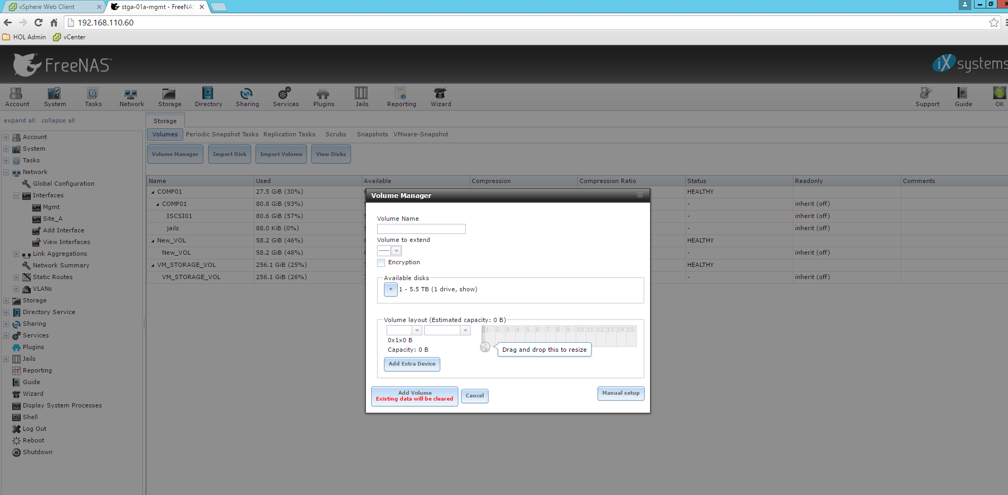

13.2 Click on + sign under Available disks, give volume name as “SVM_STORAGE_VOL” and click on “Add Volume”. This will create a new volume of size XTB.

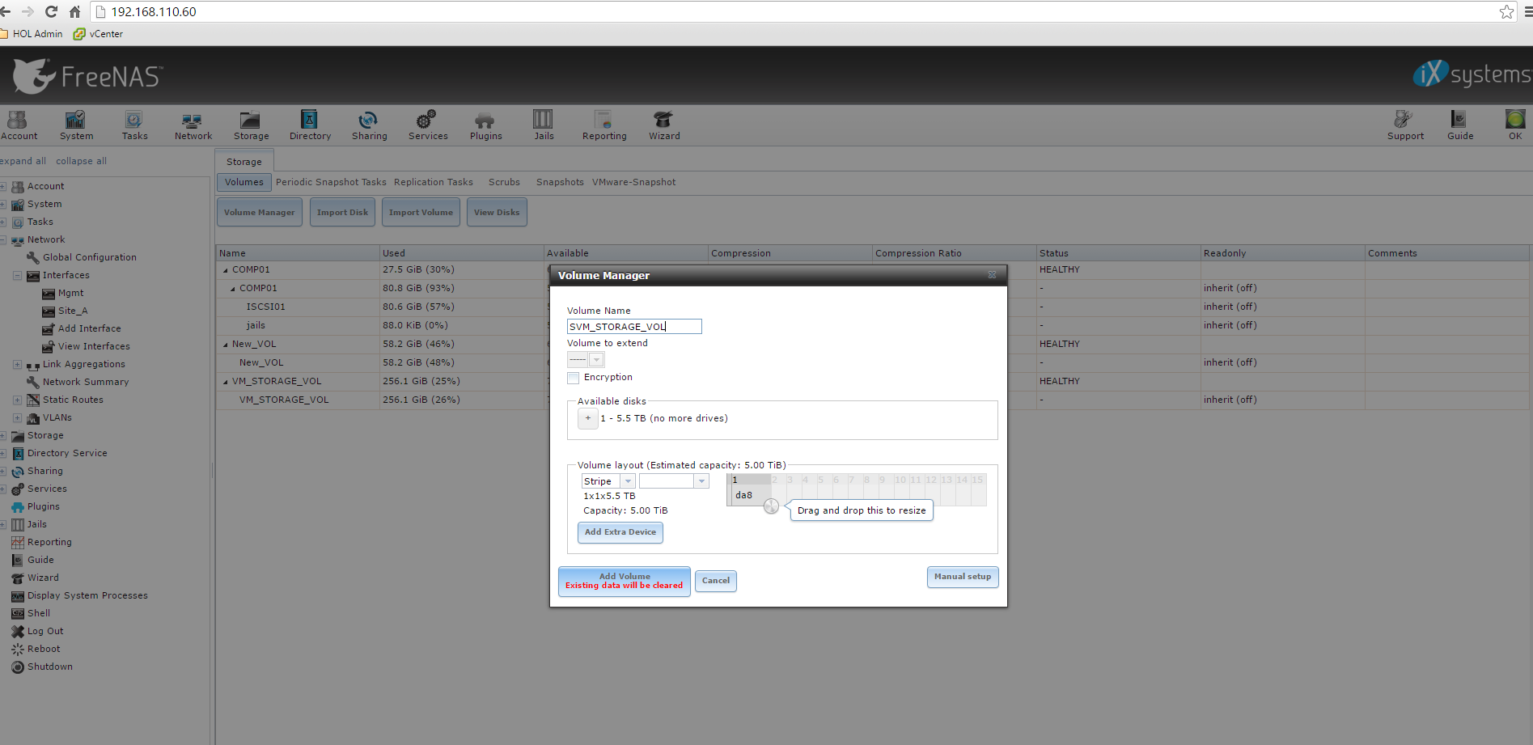

13.3 Go to Sharing->Block(iSCSI) -> Extents and click on Add Extent.

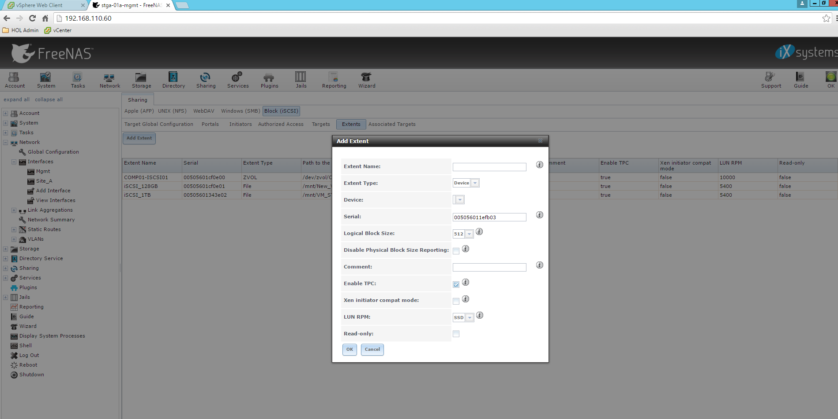

13.4 Enter the extent name as “iSCSI_2TB” (assuming the disk size is 2 TB), select Extent Type “File”, path to extent as “/mnt/SVM_STORAGE_VOL/iSCSI_2TB” and give appropriate extent size, 2TB in this case. Click on “OK”. This will create a new Extent “iSCSI_2TB”.

Note: If you select browse, you may not see the filename iSCSI_2TB. Specify the full pathname including the filename. Also please specify the extent size appropriately. Extent size of auto does not work when the file does not exist. When creating the extent for the first time,the file is not present.

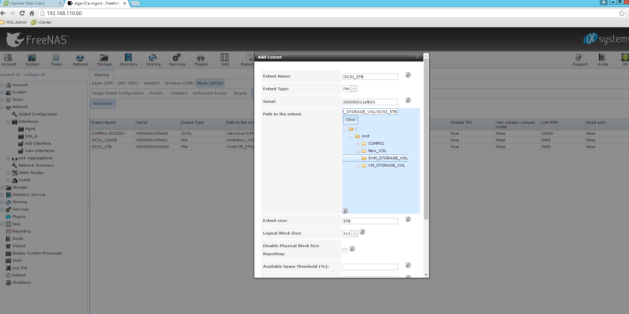

Also **enable** “checkbox” for “Disable Physical Block Size Reporting” for each new Add-Extent.

A screenshot of a cell phone

Description generated with very high confidence

13.5 Go to Sharing->Block(iSCSI) -> Associated Targets and click on “Add Target/Extent”. Select the target as “sitea”, LUN ID as “1” (select unused LUN ID) and Extent as “iSCSI_2TB”. Click on “OK”. This will create a new target to the extent created above.

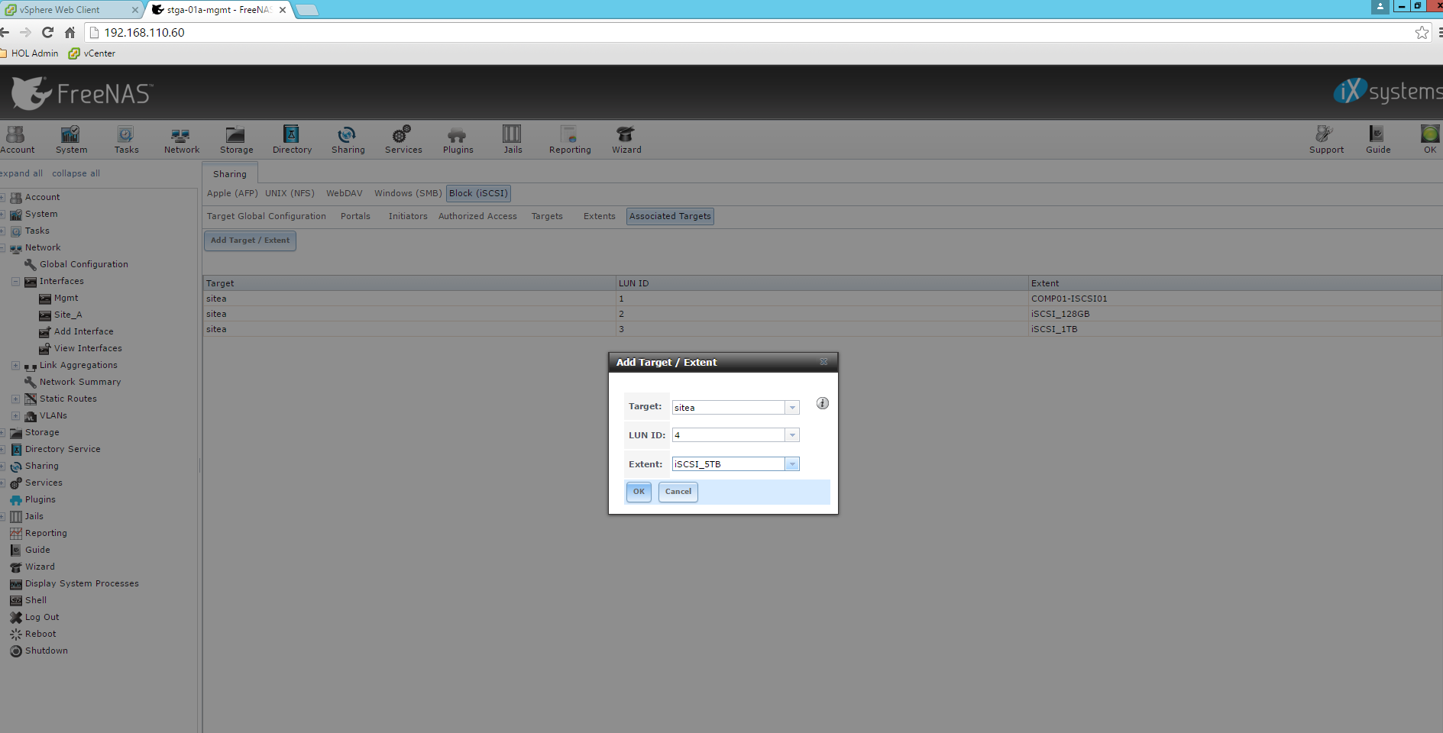

13.6 Repeat the steps from 12.1 to 12.6 for the other FREENAS servers by logging into [http://192.168.110.62/](http://192.168.110.60/), [http://192.168.110.63/](http://192.168.110.60/) and [http://192.168.110.64/](http://192.168.110.60/)

1. Next step is to mount these as data stores in the vCenter. In the vCenter Web UI, go to Storage-> Datastores -> New Datastores. Select location as “ScaleCluster1” and Type as “VMFS”. Give the Datastore name as “SVM-DataStore-1”. In “select a host to view its accessible disks/LUNs:” select any of the esx-scale host. After this, select 1280GB storage volume that was created and click on Next.

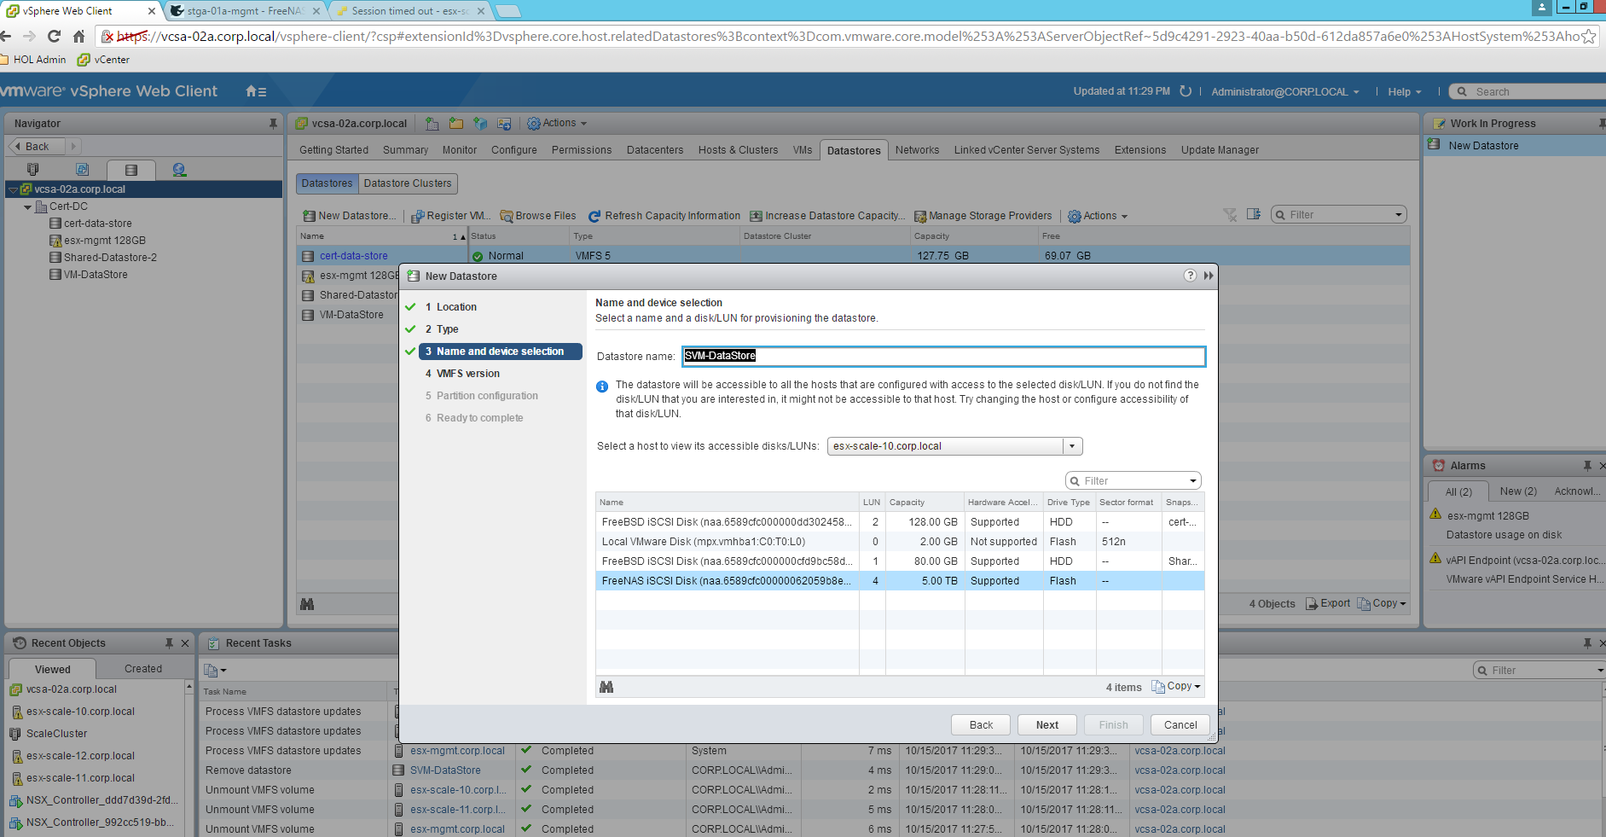

14.1 Do not change any of the configurations in the subsequent page you get after Next button. Finally click on “Finish”. This will create a “SVM-DataStore-1” of size 1280GB on ScaleCLuster1. Repeat the above steps for mounting the other datastores

"SVM-DataStore-2" on "ScaleCluster2"

"SVM-DataStore-3" on "ScaleCluster3"

"SVM-DataStore-4" on "ScaleCluster4"

14.2 The above step will also make “SVM-DataStore-1” visible on all the scale hosts, if not, rescan the VMFS volumes in the hosts by executing the action "7: to do storage scan on the scale hosts" in scale_test_bed powercli script.

1. For Partner Management Console VM, use the static IP address as 172.17.11.12/23 and gateway as 172.11.10.1, set the domain name as PMC.corp.local
2. Perform the necessary Scale testing with the configured test bed.

Select option "14" to do Host Preparation. It will ask for start and end Scale cluster index.

If you enter start as 1 and end as 4, it initiates Host Preparation and monitors the status in all the 4 scale clusters, one after the other.

Select option "15" to do Guest Introspection or Partner SVM deployment. After selecting this option, it asks for start and end Scale cluster index. It will also ask you to enter the service name of the Partner Service or the Guest Introspection to be deployed. You need to enter the service name within quotes. For Guest introspection, enter "Guest Introspection". The deployment will be done sequentially in all the scale clusters you have entered.

Note: The above will also resolve any alarms raised during the deployment.

We have also added option "16" which will monitor and resolve alarms raised in the Service VM deployment. This option can be ignored as these operations are carried in the option "15". However, in case, you have initiated the deployment manually and if you are not running option "15", you can select option "16" to monitor the Service VM deployment status.

**Winding down the Horizontal scale test environment**

1. Once all the testing is done, go to pyCharm and run testif.py. Select option “2. Remove ESX Scale” and press Enter. This will power off all the esx-horizontal-1 to esx-horizontal-32 and esx-horizontal-1-1 hosts and remove them from the vAPP. You can monitor the job by selecting option 6 and giving job id.

This option takes care of deleting all the Scale ESXi resources for the other vApps to use. Step-by-step clean-up instructions are given in the Miscellaneous section. These steps can also be used to do the clean-up.

**Miscellaneous:**

The Horizontal hosts esx-horizontal-1 to esx-horizontal-32 have

1. Management IP addresses starting from 192.168.110.21 to 192.168.110.52. All of them have mask 255.255.255.0
2. VMKernel(vmk1) IP addresses accessing iSCSI Storage starting from 10.10.21.21 to 10.10.21.52. All of them have mask 255.255.254.0

The Horizontal hosts esx-horizontal-1-1 to esx-horizontal-32-1 have

1. Management IP addresses starting from 192.168.110.101 to 192.168.110.132. All of them have mask 255.255.255.0
2. VMKernel(vmk1) IP addresses for accessing iSCSI Storage starting from 10.10.21.61 to 10.10.21.92. All of them have mask 255.255.254.0

The Scale Host esx-scale-1 has

1. Management IP address 172.17.11.1, mask 255.255.254.0
2. VMKernel(vmk1) IP address for accessing iSCSI storage is 10.10.20.1

The Scale hosts from esx-scale-2 to esx-scale-254 have

1. Management IP address starting from 172.17.10.2 to 172.17.10.254. All of them have mask 255.255.254.0
2. VMKernel(vmk1) IP addresses for accessing iSCSI Storage starting from 10.10.20.2 to 10.10.20.253(except esx-scale-55, esx-scale-60, esx-scale-253 and esx-scale-254). All of them have mask 255.255.254.0
3. esx-scale-55 has vmk1 IP address as 10.10.20.253, mask 255.255.254.0
4. esx-scale-60 has vmk1 IP address as 10.10.20.254, mask 255.255.254.0
5. esx-scale-253 has vmk1 IP address as 10.10.21.1, mask 255.255.254.0
6. esx-scale-254 has vmk1 IP address as 10.10.21.2, mask 255.255.254.0

The Scale Host esx-scale-255 has

1. Management IP address 172.17.11.2, mask 255.255.254.0
2. VMKernel(vmk1) IP address for accessing iSCSI storage is 10.10.21.3, mask 255.255.254.0

The Scale Host esx-scale-256 has

1. Management IP address 172.17.11.3, mask 255.255.254.0
2. VMKernel(vmk1) IP address for accessing iSCSI storage is 10.10.21.4, mask 255.255.254.0

The esx-mgmt Host has

1. Management IP address 192.168.110.55, mask 255.255.255.0
2. VMKernel(vmk1) IP address for accessing iSCSI storage is 10.10.20.55, mask 255.255.254.0

The esx-mgmt-2 Host has

1. Management IP address 192.168.110.56, mask 255.255.255.0
2. VMKernel(vmk1) IP address for accessing iSCSI storage is 10.10.21.5, mask 255.255.254.0

There are 5 FREENAS Servers

1. Stgb-01a VM has Management IP address as 192.168.110.60/24 and IP for accessing iSCSI is 10.10.20.60/23
2. Stgb-01a-1 VM has Management IP address as 192.168.110.61/24 and IP for accessing iSCSI is 10.10.21.161/23
3. Stgb-01a-2 VM has Management IP address as 192.168.110.62/24 and IP for accessing iSCSI is 10.10.21.162/23
4. Stgb-01a-3 VM has Management IP address as 192.168.110.63/24 and IP for accessing iSCSI is 10.10.21.163/23
5. Stgb-01a-4 VM has Management IP address as 192.168.110.64/24 and IP for accessing iSCSI is 10.10.21.164/23

MTU is set to 8000 in the servers as well as all of the VMK.

There are 256 Linux Guest VMs, IP addresses are

1. Linux-VM1 has 172.16.11.1/23
2. Linux-VM2 to Linux-VM254 has IP address ranging from 172.16.10.2 to 172.16.10.254
3. Linux-VM255 has IP 172.16.11.2/23, Linux-VM256 has IP 172.16.11.3/23

There are 256 Tiny core Linux Guest VMs, IP addresses are

1. Tiny-Linux-VM-1 to Tiny-Linux-VM-255 has IP address ranging from 172.18.10.1/16 to 172.18.10.255/16
2. Tiny-Linux-VM-256 - IP 172.18.11.1/16

ESX-per host is used for performance.

IP address is 192.168.110.134 statically configured

Storage address 10.10.21.165/24

And MTU is 8000 on the VMK adapter.

VSwitch is storage_v_switch on esx-perf and MTU is 8000 on the vSwitch.

Note: if you are going to have nested ESX on esx-perf and need storage access at 8000 MTU then the MTU of the vSwitch needed to be increased.

**Cleaning up the test bed (optional):**

1. Unmount the “SVM-DataStore-1”, "“SVM-DataStore-2”, “SVM-DataStore-3” and “SVM-DataStore-4” in the vCenter on all the hosts.

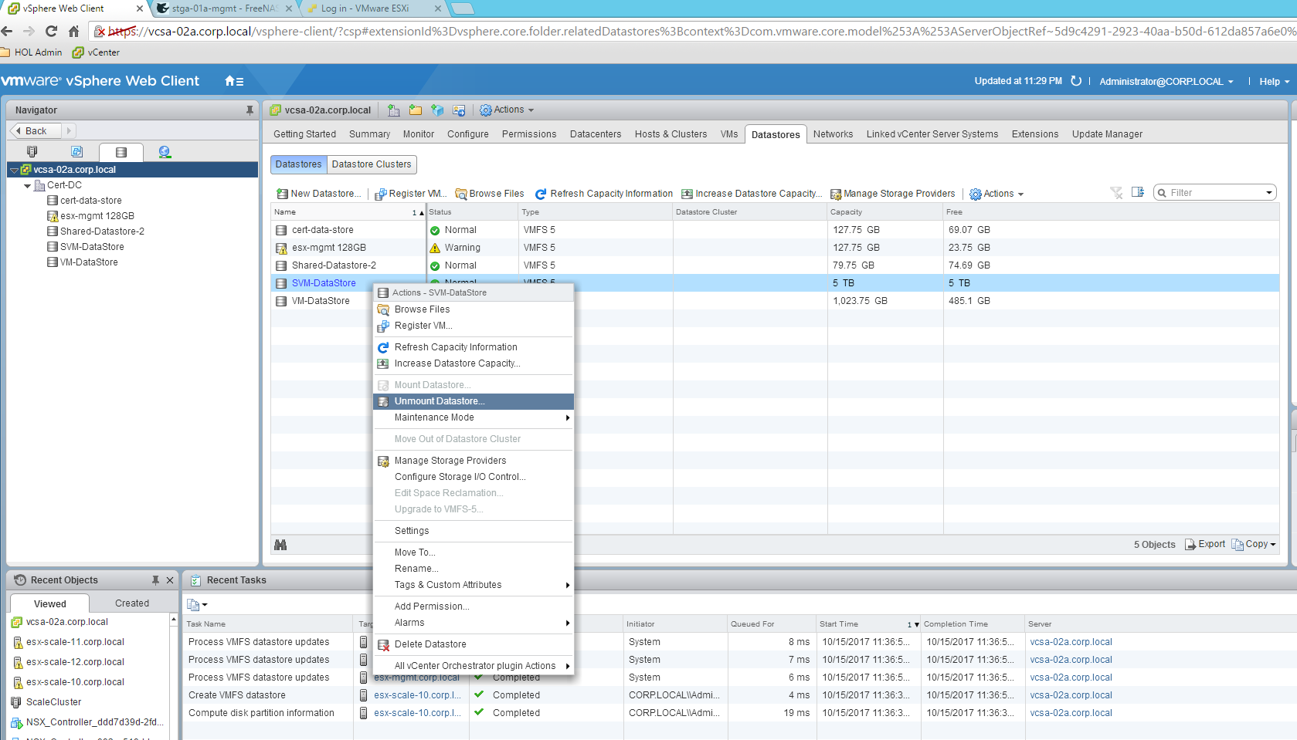

1. After the datastores are unmounted, select “Delete Datastore” option. This will delete the datastores on all of the hosts.
2. We need to remove the storage volume in the FreeNAS server. Follow the below steps in all the 4 FREENAS Servers:
   1. In the FreeNAS UI, go to Sharing->Block(iSCSI) -> Associated Targets. Delete iSCSI_5TB target

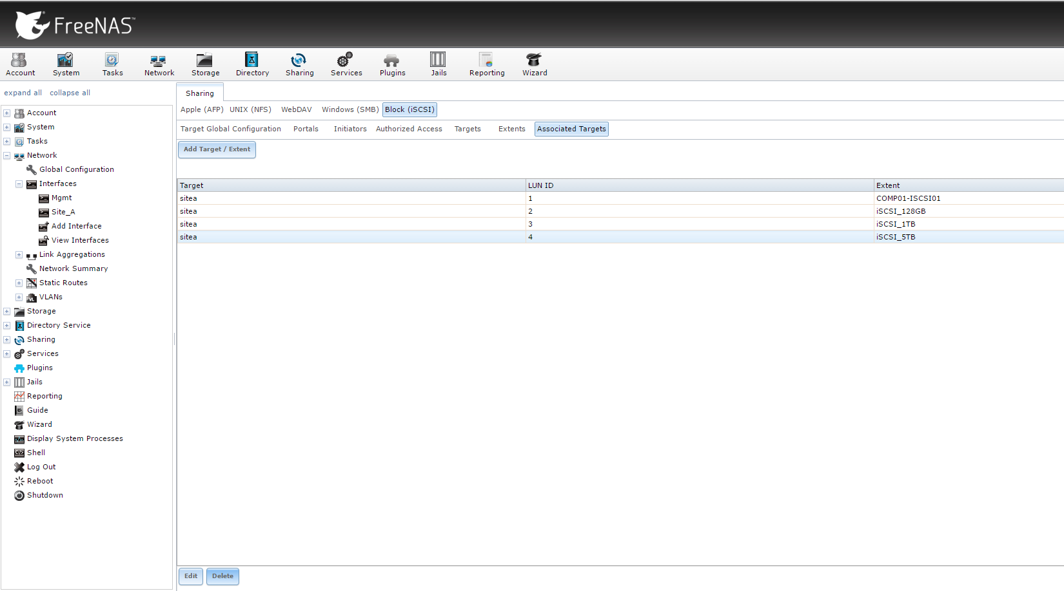

* 1. Go to Sharing->Block(iSCSI)->Extents, delete iSCSI_5TB extent. Mark the checkbox “Delete underlying file”

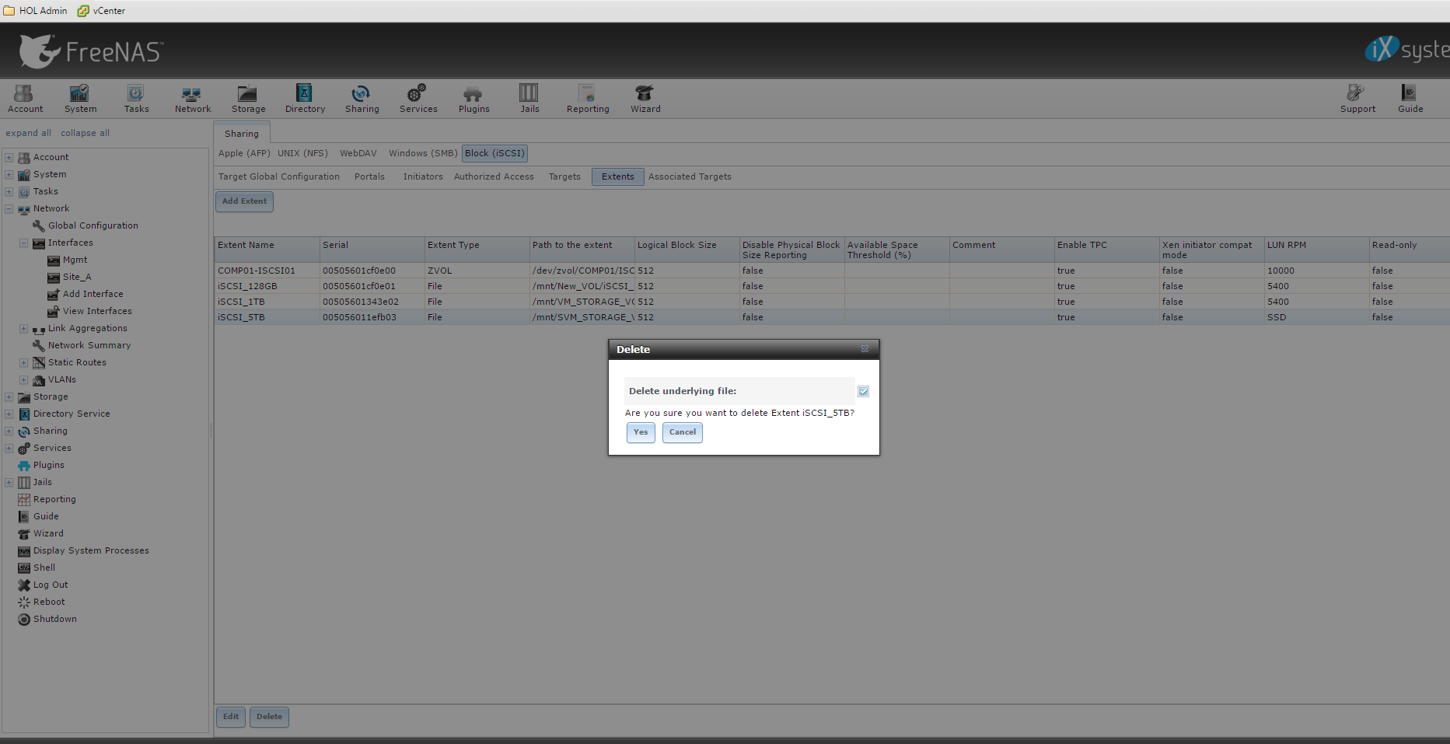

* 1. Go to Storage->Volume Manager, detach “SVM_STORAGE_VOL”

iS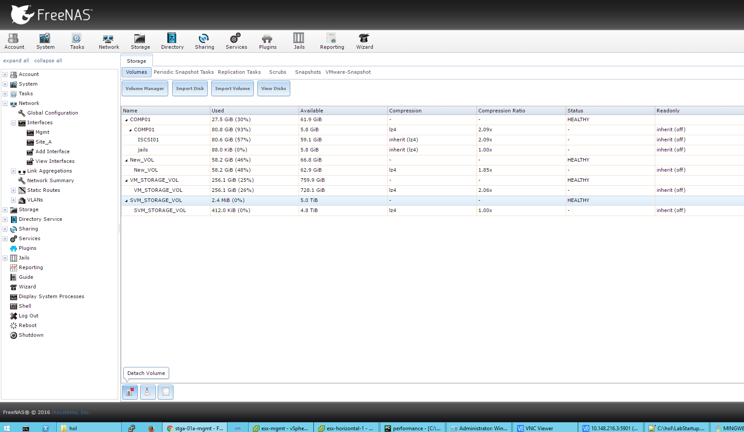

1. Shutdown all the Guest VMs by executing "option 13: to shutdown Linux VMs "
2. Detach the scale ESXi hosts from the vDS by executing the action "8: remove scale hosts from vDS" in scale_test_bed powercli script.
3. Unregister all of the ESXi hosts, VMs using the option "9: un-register VMs from the scale hosts" in scale_test_bed powercli script.
4. Remove all of the scale ESXi hosts from vCenter by executing the action "10: remove scale hosts from vCenter" in scale_test_bed powercli script.
5. Shutdown all of the scale ESXi hosts by executing the action "11: shutdown the scale hosts" in scale_test_bed powercli script. This step is not required as we are executing the Horizontal test at the last. The vApp will be deleted after this test.
6. In the pyCharm which is running testif.py, select option “2. Remove ESX Scale” and press Enter. This will power off all the esx-horizontal-1 to esx-horizontal-32 and esx-horizontal-1-1 hosts and remove them from the vAPP. Again, you can monitor the job by selecting option 6 and giving job id.